LRTA Music Summer Assignment 2022
Soundtrack of the Summer Name:_________________
Listening to music can bring back memories and transport us back to memorable times in out lives. A song might remind you of your childhood, and old friend, a family event or a significant time in your life.

Create a soundtrack (school appropriate) that best represents your summer break. Band, Strings, Chorus and General Music class need to add one song that is just instrumental (no singing/words). What mood or feelings best sum up the summer for you? Is there a common theme you can find to describe your vacation?

Create a playlist of 8-10 songs (school appropriate) that best represents your summer soundtrack. Include the title of the song and the name of the artist on your playlist.

For each song you choose, please write at least 3-4 sentences to explain why you picked the song. Be sure to explain the song’s significance to you and your experiences.
- What was it about the song that appealed to you?
- What line or lines in the song really represent you and your life?
- What themes or ideas in the song reminded you of your summer?

Create cover or playlist art in the box to the right. Keep in mind the mood or feeling of the songs you have chosen and try to make your cover reflect those themes and ideas. What colors, symbols, and pictures best represent the music you have chosen for your soundtrack.
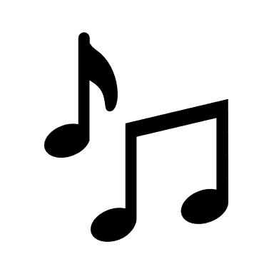
Title:______________________________ Artist:______________________

Title:______________________________ Artist:______________________

Title:______________________________ Artist:______________________

Title:______________________________ Artist:______________________

Title:______________________________ Artist:______________________

Title:______________________________ Artist:______________________

Title:______________________________ Artist:______________________

Title:______________________________ Artist:______________________

Title:______________________________ Artist:______________________

Title:______________________________ Artist:______________________

My favorite song on my playlist is…..

